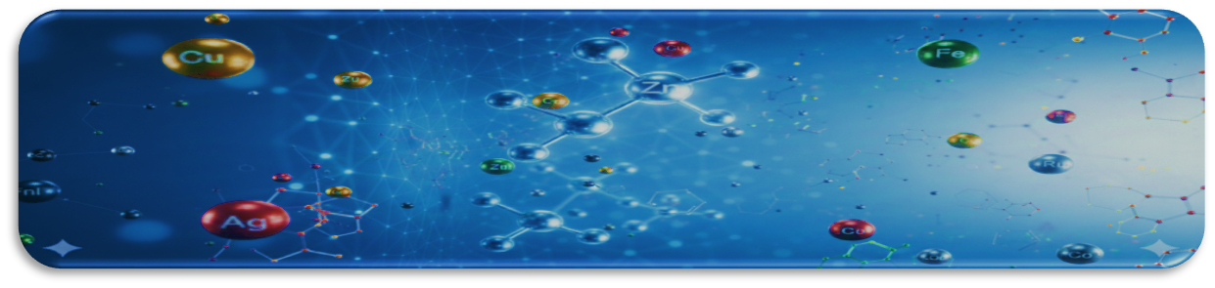
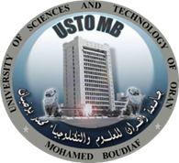
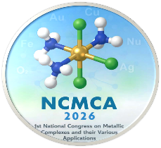
1stNational Congress on Metallic Complexes and their various Applications NCMCA 2026
Oran, 20th& 21st September
Laboratoire de Chimie et d’Electrochimie des Complexes Métalliques (LCECM)
Faculté de Chimie, USTO-MB

TOPIC I: Environmental Applications (example)

JKJKJKJKJK

Title of the Communication (Times New Roman, font size 14, Bold)
First Author¹, Second Author^{1,2}, Third Author³ (Times New Roman, font size 11, Bold)

¹ Department, Faculty, University, city, Postcode, Country (Times New Roman font size 10, Italic)

²Department, Faculty, University, city, Postcode, Country (Times New Roman font size 10, Italic)
³Industry, City, PostCode, Country.
Corresponding Author Email : ……..
(Times New Roman font size 10, Italic, underlined, centred)

Abstract
The abstract should be between 250 and 300 words maximum, justified, Times New Roman, font size 10, single spaced. The structured abstract should be brief and comprehensive, succinctly summarizing the study's objective, the methods used, the main results and the conclusions. It allows readers to quickly scan the content.
In the “Keywords” section, three to six keywords—whether single or compound—must be provided, typed in 9-point Times New Roman font, and listed in alphabetical order.

Keyworlds :Keyworld1, Keyworld2, Keyworld, Keyworld, Keyworld (3-6 Keyworlds)

