People’s Democratic Republic of Algeria
University of Science and Technology of Oran- Mohamed Boudiaf
Faculty of Chemistry
Laboratoire de Chimie et d’Electrochimie des Complexes Métalliques
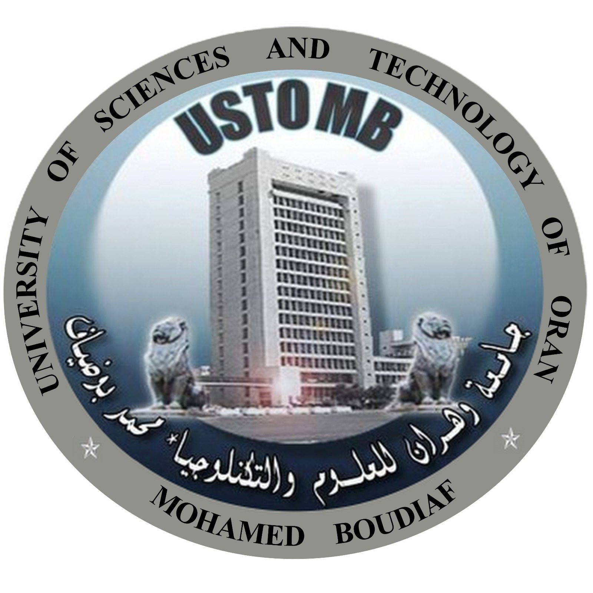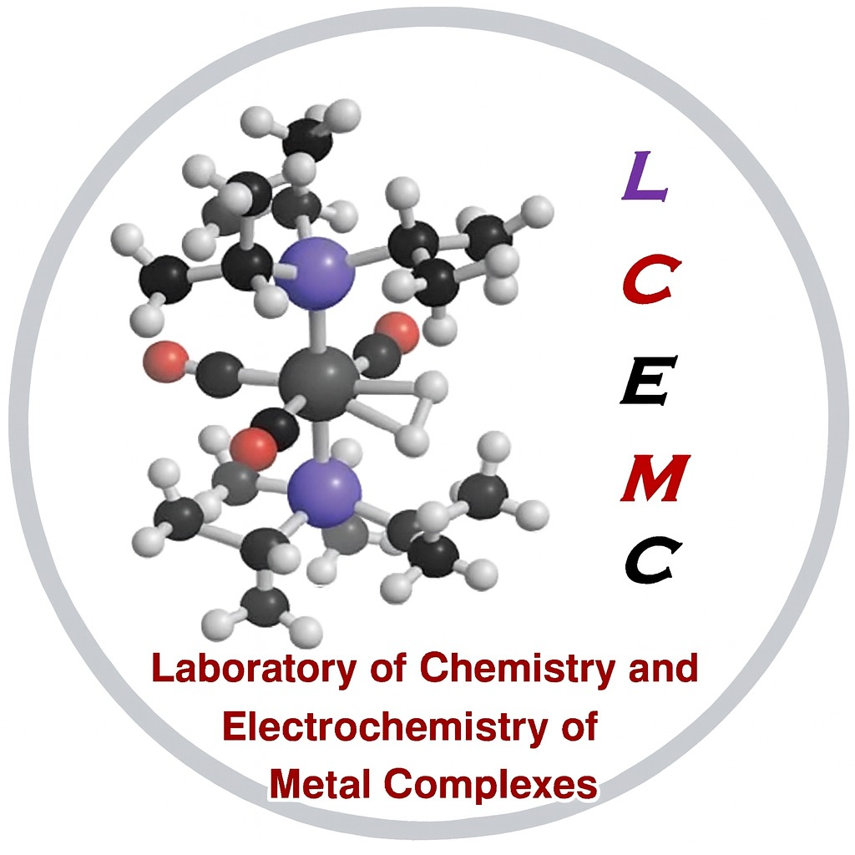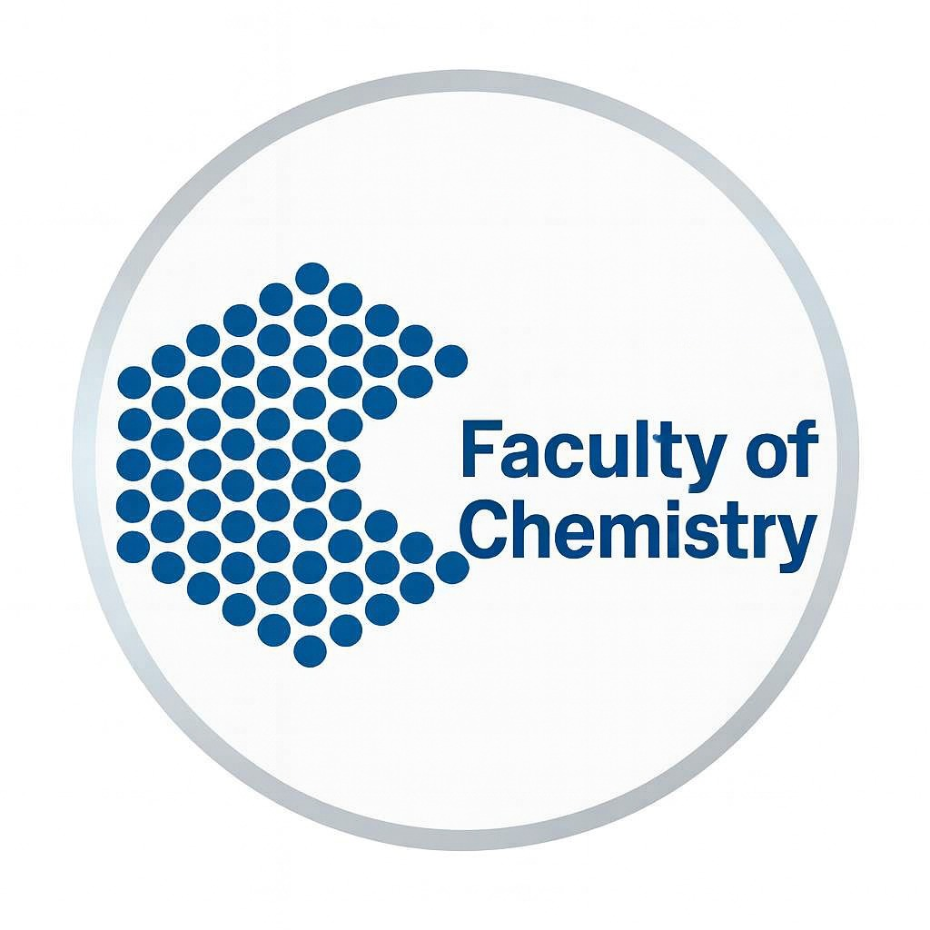
1stNational Congress on Metallic Complexes and their various Applications
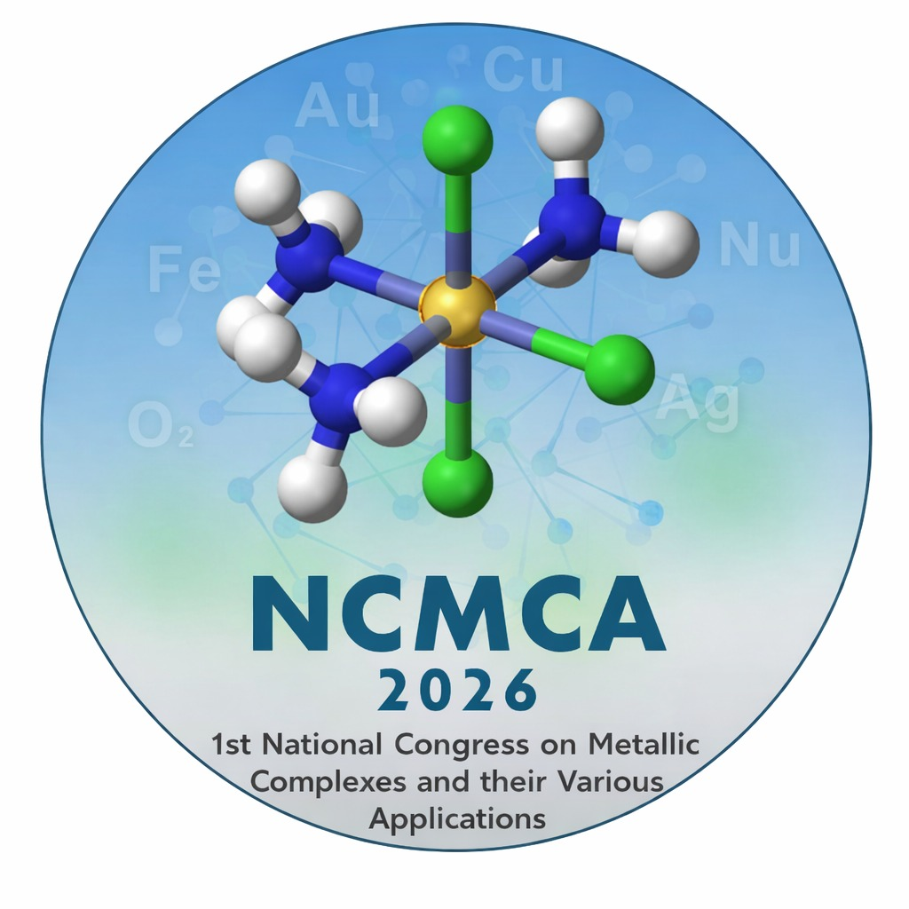
October 28 and 29, 2026
Oran, Algeria

Conference Chair | Honorary Chair
Pr. Tayeb BENABDALLAH  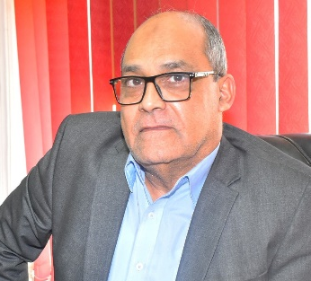 | Pr. Emeritus, Ahmed HAMOU  Pr. Abdelaziz BENDRAOUA
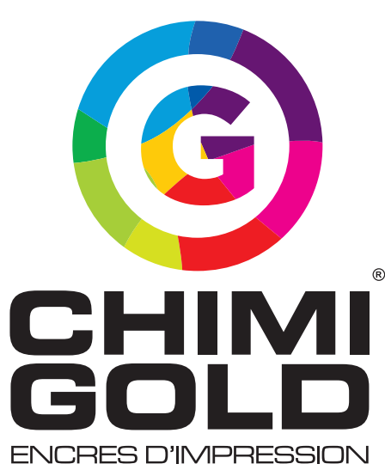

Preamble
The first National Congress entitled "Metal Complexes and their various Applications" is motivated by the importance of metal complexes and the crucial role they play in the chemical industry and living organisms. Their unique properties make them indispensable in a wide range of applications, from industrial catalysis and organic synthesis to medical imaging, medicine and pharmacology, materials science and energy storage. The 1st NCMCA 2026 will serve as a platform for exchange and collaboration between researchers, teacher-researchers, doctoral students, engineers and other experts in chemistry, at the national level, on Coordination Chemistry and Metal Complexes and their Applications in all of these major and innovative fields.
Registration Fees
PhD Student | 3000 DA
Academic Researchers | 6000 DA
Industrialists | 9000 DA
Stands | 5000 DA

Registration fees doesn't cover the
participant accommodation
Registration fees for NCMCA 2026 include :

- Conference materials and documentation, coffee breaks and lunch provided throughout all the conference days.
- Certificate of attendance, signed by the conference president.

 NCMCA26@univ-usto.dz

4
3
2
1
TOPICS

Topic1: Removal of various metallic pollutants using different extraction techniques: liquid-liquid, solid-liquid, two-aqueous phases, membrane extrations, etc.
Topic 2: Development of metal complex-based catalysts and their application in chemical reaction engineering.
Topic 3: Synthesis, structural analysis and medical applications, in therapeutics and diagnostics, of chelating ligands and various metallic complexes.
Topic 4: Metallic complexes in the Development of lithium-ion batteries and redox batteries; modified electrodes; Fuel cells.

Dr. Abdelkader BENHALIMA (Univ-Saida)
Dr. Fatiha SEBIH (USTO-MB)
Dr. Fawzia SELADJI (USTO-MB)
Dr Radjaa MEGHERBI (USTO-MB)

ABSTRACT SUBMISSION
Abstracts submitted to the 1st NCMCA 2026 Congress are examined by the scientific committee.
Abstracts must be submitted exclusively vie the following at the link
https://docs.google.com/forms/d/e/1FAIpQLSfprBu7aPvvlfeBn9q4UDoi2PdFahZ4DHGUOPnDn6i43_41Yg/viewform?usp=header&amp;pli=1&amp;authuser=0
Authors: Centered, Times New Roman 12, speaker's name underlined.
Affiliations: Centered, Times New Roman 10. Email: Centered, Times New Roman 11.
Abstract: 300-350 words, justified, Times New Roman 12, 1.5 line spacing.
Keywords: 3-5 words, Times New Roman 12. Language: English or French.
Posters: Size 80 cm x 100 cm.
IMPORTANT DATES
-Deadline for submission of abstracts:
20/08/2026
- Notification of acceptance:
01/09/2026
- Congress date:
28 and 29/10/2026

Contact Details
NCMCA 2026 secretariat
Université des Sciences et de la Technologie d’Oran-Mohamed Boudiaf, BP-1505 EL-M’naouer Oran
E-mail : NCMCA2026@univ-usto.dz

ORGANIZING COMMITTEE
President: Dr. Mohamed KARMAOUI
Vice-president: Dr. Fatima-Zohra
GUEFAI
Members
Dr. Aicha ZERROUKI (Ecole ESSBO)
Dr. Souhila BELHOCINE (Univ-ORAN1)
Dr. Nabil BENABDALLAH (USTO-MB)
Dr. Faiza Nabila BOUHA (USTO-MB)
Dr; Ryad KARBADO (USTO-MB)
Dr. Oumayma DEFFALLAH (USTO-MB)
Dr. Chakib ALAOUI (USTO-MB)
Dr. Adnane HALIMA SALEM (ENPO)
Miss. Lahouaria ELGOUTNI (USTO-MB)
Dr. Nawel METAHRI (USTO-MB)
Dr. Lamia AMAROUCHE (USTO-MB)
Dr. Affaf TABBICHE (USTO-MB)
Dr. Nardjesse NEMICHE (USTO-MB)
Dr. Meriem BELGUENDOUZ (USTO-MB)
Dr. Fatima ASSASSI (USTO-MB)
Dr. Sarrah MISSOUM (USTO-MB)
Dr. Fadia MERABET (USTO-MB)
Dr. Fatima Zohra CHAIDA (USTO-MB)
Doc Wafaa GHALEM (USTO-MB)
Doc Ismahane BENALI (USTO-MB)
Dr. Nawel DRICI (USTO-MB)
Dr. Fatiha ABIDALLAH (USTO-MB)

SCIENTIFIC COMMITTEE
President: Pr. Mohammed HADJ YOUCEF
Vice president: Pr. Hasnia REFFAS
Members
Pr. ADEL ALI Othmane (USTO-MB)
Pr. Rachid MEGHABAR (Univ-ORAN1)
Pr. Hadj HAMAIZI (Univ-ORAN1)
Pr. Hafida MILOUDI (Univ-ORAN1)
Pr. Mostefa KAMECHE (USTO-MB)
Pr. Aicha KHENIFI (USTO-MB)
Pr. Noureddine TCHOUAR (USTO-MB)
Pr. Amine MORSLI (USTO-MB)
Pr. Mohamed BELAKADI (USTO-MB)
Pr. Nesserine HAMINI-KADAR (Univ-ORAN1)
Pr. Khalil OUKEBDANE (Univ-Tlemcen)
Pr. Bouhdjer BOUKOUSSA (USTO-MB)
Pr. Tarik ATTAR (Univ-Tlemcen)
Pr. Djamila HARRACHE (Univ. Djillali LIABES)
Pr. Belkacem BENGUELLA (Univ-Tlemcen)
Pr. Mohamed Amine MEHDID (USTO-MB)
Dr. Zoulikha KHOUBA (USTO-MB)
Dr. Ahcene AIT AMER (Univ. Djillali LIABES)
Dr. Sadia BOUKRERIS (USTO-MB)
Dr. Nadia BOCEIRI (Univ-ORAN1)
Dr. Sihem DALI YOUCEF (USTO-MB)
Dr. Nadia BELHADJ (USTO-MB)
Dr. Meriem KHIAT (USTO-MB)
Dr. Fatima BERREBIA (USTO-MB)
Dr. Zoulikha KHIATI (USTO-MB)
Dr. Wassila ABOURA (Univ-ORAN1)
Dr. Abdelmounaim SAFER (USTO-MB)

